Investing in an Election Year

What impact could the 2020 election have on your portfolio?
There are many things that don’t mix well – orange juice and toothpaste, water and a keyboard, flies and Chardonnay. But there’s one thing that never, ever mixes well – investing and elections. This is because politics matter far less to reaching our goals than the investing, saving and planning decisions we make when crafting a long-term financial strategy.
Not only is it impossible to predict who will win an election, it’s even less possible to predict how the market will react. Why? Because elections are about more than one person or variable. It’s about local races and national races, it’s about the president and Congress, it’s about governors and judges.
Not only that, the market isn’t concerned with politics as much as policies. What are the policies of the potential winner? What are the odds they can actually enact those policies? If they can, how will that affect one of the world’s most complex economies?
See how hard this is? And we’ve only barely scratched the surface on why you should never make investment changes based on an election. But let’s put all that aside and look at pure data. How has the market reacted to various political regimes in U.S. history? Take a look at this chart, courtesy of Strategas:
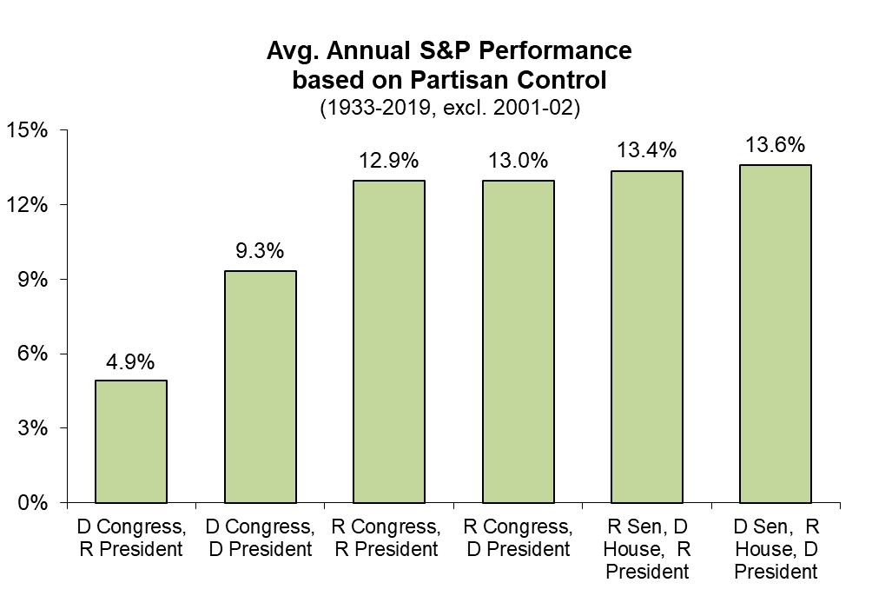
Note: Data excludes 2001 due to Sen. Jim Jeffords changing party mid-year

You might notice a few things:
- The market has averaged positive performance through every possible party combination. Full stop. The market has persevered through peace and war, high tax and low tax, pro-nationalism and pro-globalization. Political party is not fundamentally different – even the worst combination averaged ~5% per year (and that can partly be chalked up to bad luck, as you’ll see shortly). That 5% is more than enough to build long-term wealth. This is not a guarantee of future performance of course – it’s just a look at the evidence we have at our disposal.
- The stock market is influenced by a ton of factors, only a handful of which are directly attributable to the president or Congress. Take the one outlier: the lower-returning R President/D Congress period. This grouping included both the 1973–1974 oil crisis and the 2008 Great Recession, two of the worst crises in market history, as well as the 1958 and 1990 recessions. While certain U.S. policy decisions may have colored these events, a tremendous amount of geopolitical and financial complexity led to the ultimate outcomes. From nonpolitical central banks and foreign national activity to shifting consumer behaviors and technological advancements, the stock market does its best to reflect every possible morsel of information it can get at any given time. If we removed just one year, 2008, from the R President / D Congress grouping, the average return would rise to 7%. Political actions are one very small piece of this pie.
Let’s look at one more chart before we wrap up: How has the stock market performed after a presidential election? Once again, a chart from our friends at Strategas shows that if we look at the history of this country, stocks tend to react positively (one year out) whether the incumbent wins or loses. There are ups and downs along the way, but the market ultimately moves on from election day regardless of the outcome.
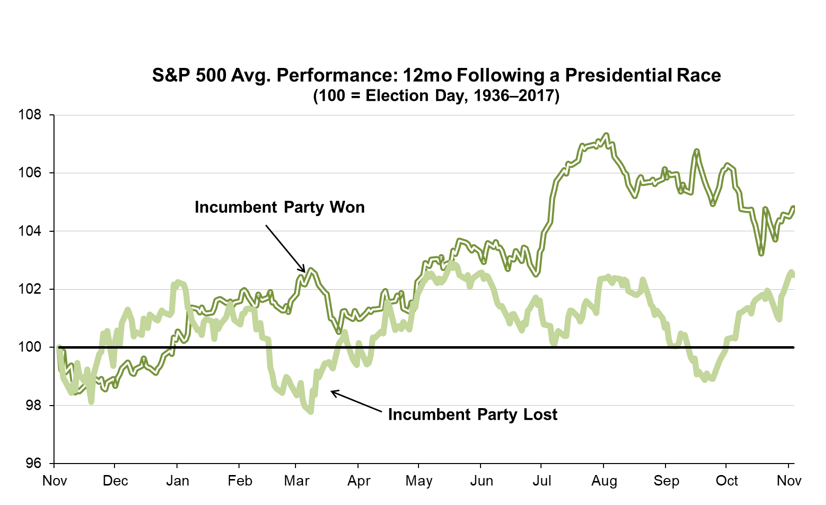
While your ultimate financial plan should never change based on an election, there are certain things to be aware of during election years – namely, volatility tends to be higher and returns tend to be lower. While most election years don’t feature a once-in-a-century pandemic, the headline volatility associated with shifting polls, campaign stumping and debate fireworks can intensify market moves. This may present good buying opportunities for savvy investors, but at the very least it is important to be aware of the chance for higher

volatility and prepare for it. Things usually calm down once the election buzz has passed and the day-to-day grind of running the country resumes.
Whether it’s true or not, the partisan divide in our country feels wider than ever. The debate is noisier, the rhetoric is harsher and social media has a way of amplifying the loudest and most controversial voices. Politics is an emotional game and, unfortunately, some of our worst biases and behavioral mistakes show up when we let emotions drive our decision-making. Investing is no different. That is why your Baird Advisor is here to work with you through the political noise and election-year volatility. They aim to help you build a robust portfolio and long-term plan, regardless of the shifting political winds.

